**To Create a Calendar Table in Power BI Using M Language**

Click on New source and select Blank Query.



Create a date first by using the syntax

**= #date(2010,1,1)**

Then Navigate to **Views** >> **Advanced Editor**

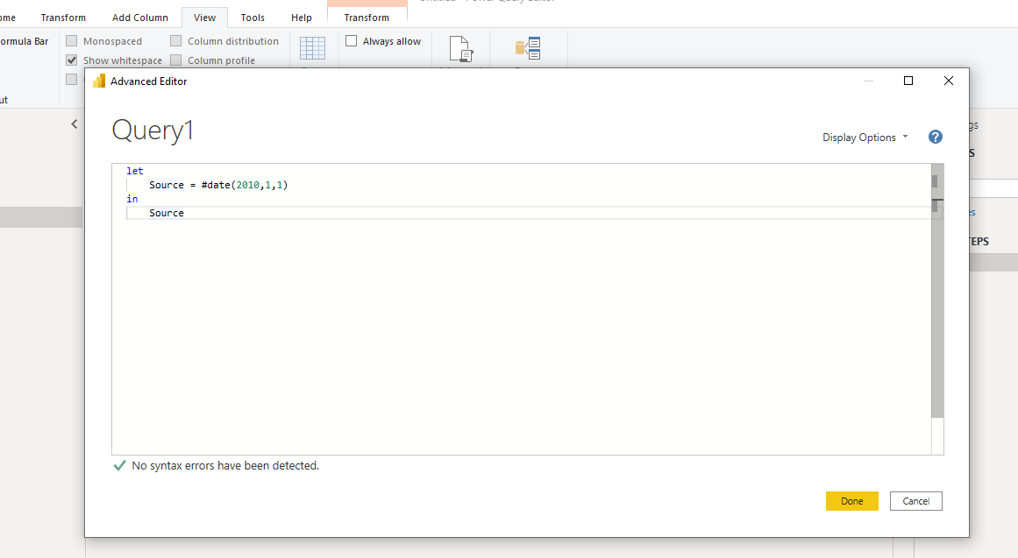

The Advanced editor has LET and IN Column the IN column calls the value from LET

**Below is the script For Calendar**

**let**

**Start_date = #date(2010,1,1),**

**Year=10,**

**Date_list= List.Dates(Start_date,10*366,#duration(1,0,0,0))**

**in**

**Date_list**

We are using **list.dates**  function ,it generates the list of dates it require

(**start_date**,

**number of years*366**(using 366 to cover both leap year and simple year),

**#duration**(days as number, hours as number, minutes as number, seconds as number) )

We are calling **Date_List** for output(in)

And the list is ready

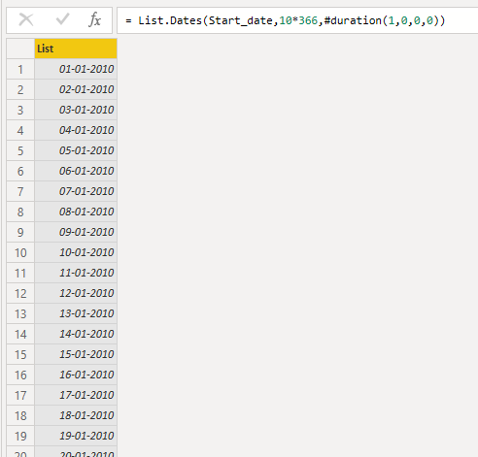

Then we convert it from list to table

